MINI STUDENT MANAGEMENT APP — DEVELOPMENT REPORT
1. PROJECT SETUP
The project was initiated from a default Flutter counter app generated by the flutter create command.
- Existing file: lib/main.dart
- Existing file: pubspec.yaml
2. DEPENDENCIES ADDED
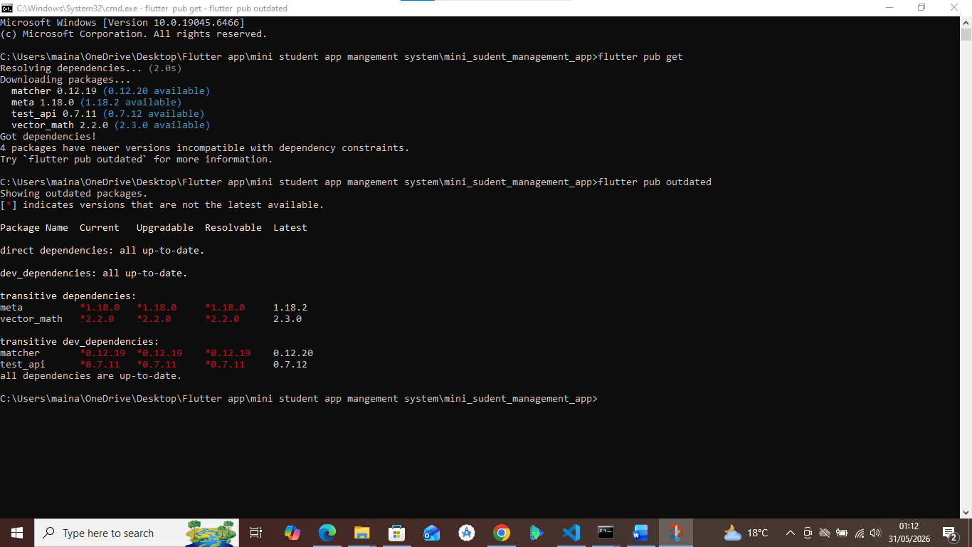
The following packages were added to pubspec.yaml:
- sqflite: ^2.3.0
- path_provider: ^2.1.0
- path: ^1.8.0
Verification: The file .dart_tool/package_config.json confirmed that all packages were downloaded successfully.
3. PROJECT STRUCTURE CREATED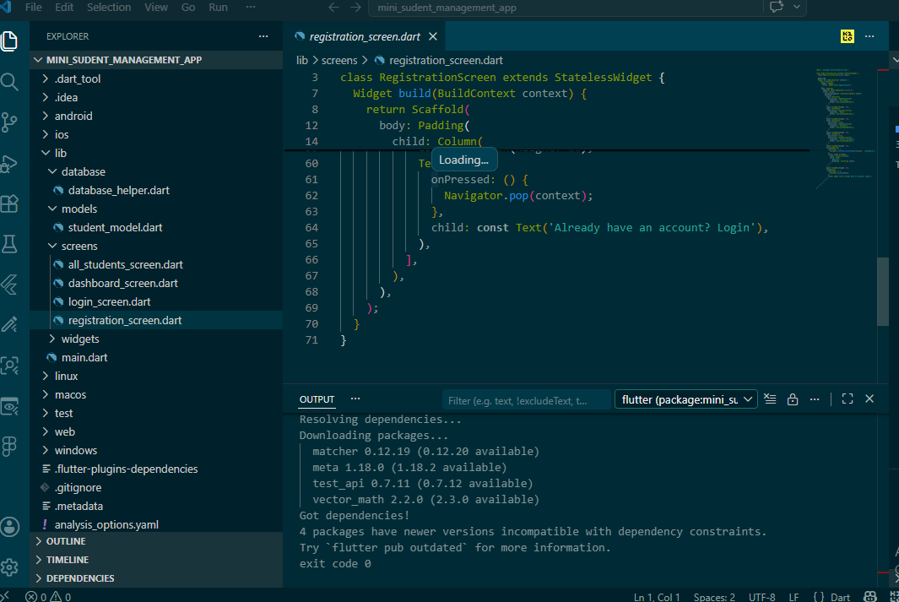
The following directory and file structure was established within the lib/ folder:
text
lib/
main.dart
screens/
login_screen.dart
registration_screen.dart
dashboard_screen.dart
all_students_screen.dart
models/
student_model.dart
database/
database_helper.dart
widgets/
custom_button.dart
custom_textfield.dart

4. MAIN.DART CONFIGURATION
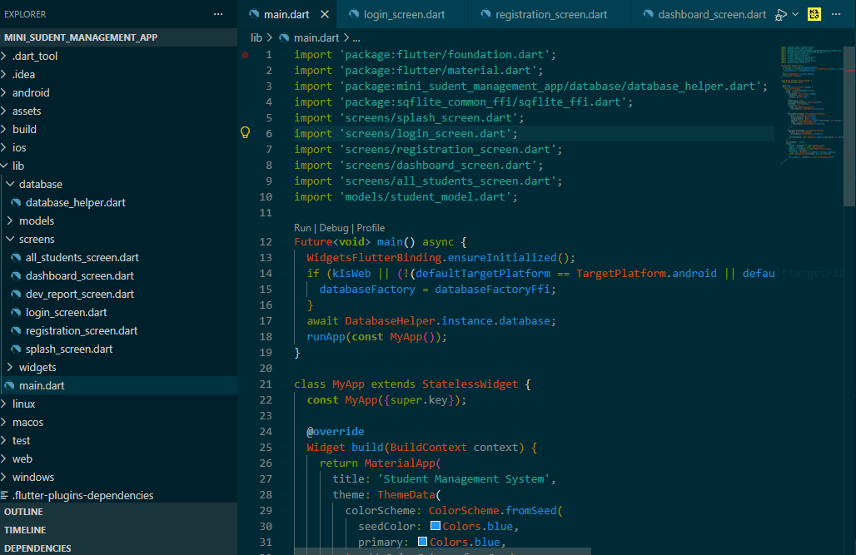
The default counter app in main.dart was completely replaced with a new configuration.
- SQLite Initialization: Added WidgetsFlutterBinding.ensureInitialized() and await DatabaseHelper.instance.database before runApp() to ensure the database is ready on startup.
- Theme: Configured MaterialApp with Material 3, setting the primary color to Colors.blue and the scaffold background to Colors.grey[50]. Global styles were applied for rounded cards (radius 12) and rounded buttons (radius 8).
- Routes: Defined named routes for navigation:
  - /splash (initial route)
  - /login
  - /register
  - /dashboard
  - /all_students
- Data Passing: The dashboard route is configured to accept a Student object via ModalRoute.settings.arguments.
5. SCREEN DETAILS
SplashScreen (lib/screens/splash_screen.dart)
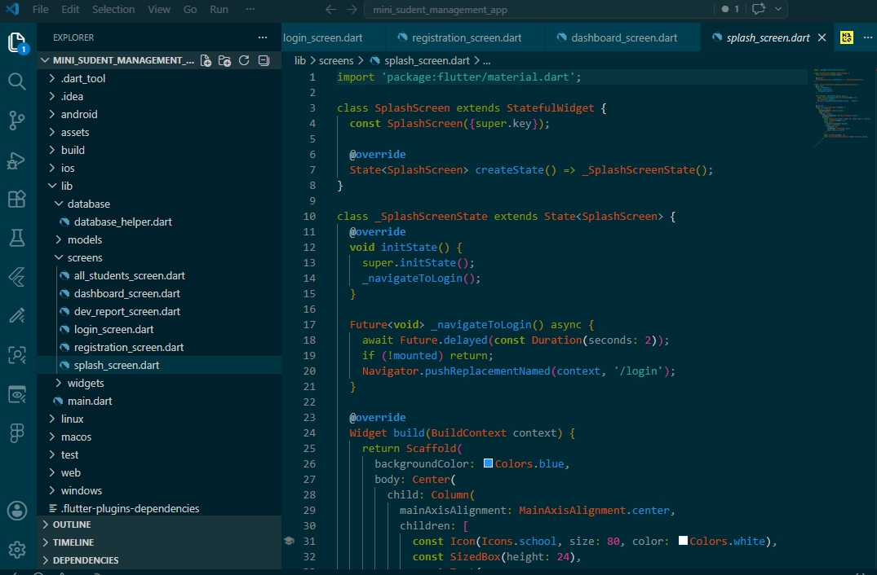
A new file created for the app launch experience. It displays a blue background with a school icon and app title for 2 seconds, along with a CircularProgressIndicator, before navigating to the /login screen.

LoginScreen (lib/screens/login_screen.dart)
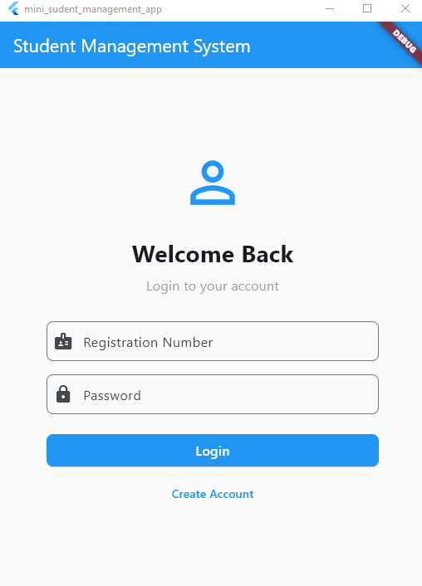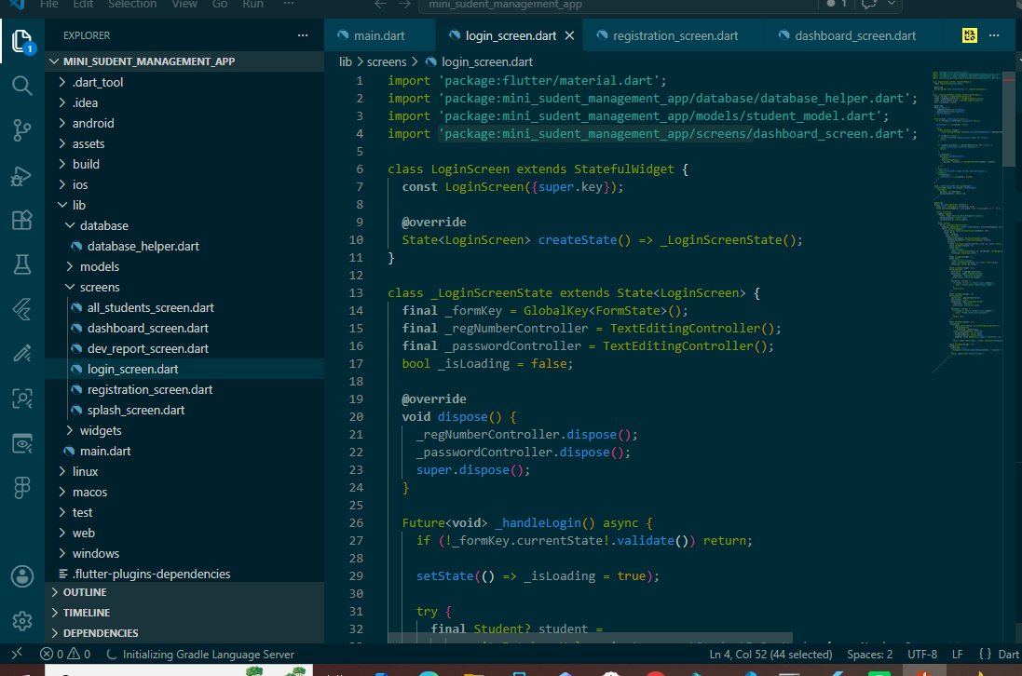
A stateful widget for user authentication.
- UI: Includes a blue AppBar, a responsive layout capped at 400px, and text fields for Registration Number and Password with form validation.
- Logic: Uses DatabaseHelper.instance.getStudentByRegNumber() to verify credentials. Displays specific error messages for "Registration number not found" and "Incorrect password."
- Navigation: Passes the authenticated Student object to the DashboardScreen on success. A "Create Account" button navigates to the registration screen.
RegistrationScreen (lib/screens/registration_screen.dart)
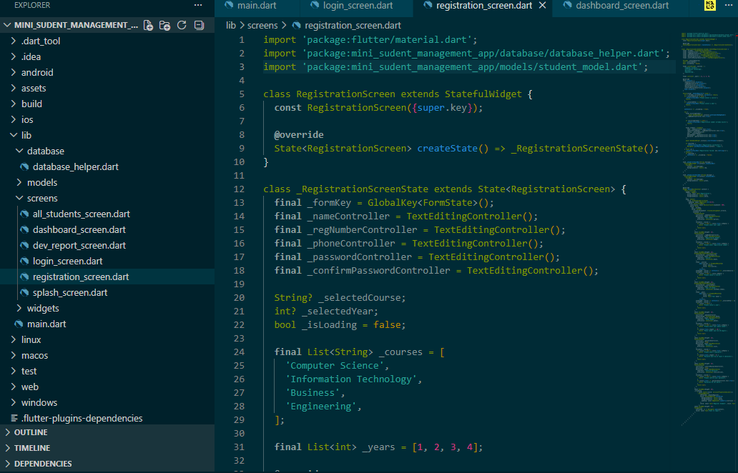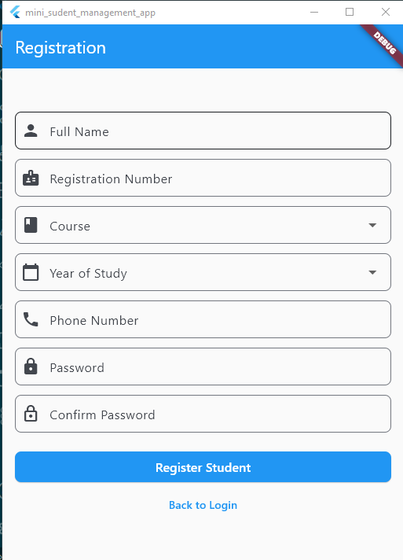
A stateful widget for creating new student accounts.
- UI: Features a blue AppBar and a responsive layout capped at 500px. Contains fields for Full Name, Registration Number, Phone (with 10-digit validation), Password, and Confirm Password, along with dropdowns for Course and Year of Study.
- Logic: On submission, it checks for duplicate registration numbers, creates a new Student object, inserts it into the database, and navigates to the login screen. A "Back to Login" button is also provided.

DashboardScreen (lib/screens/dashboard_screen.dart)
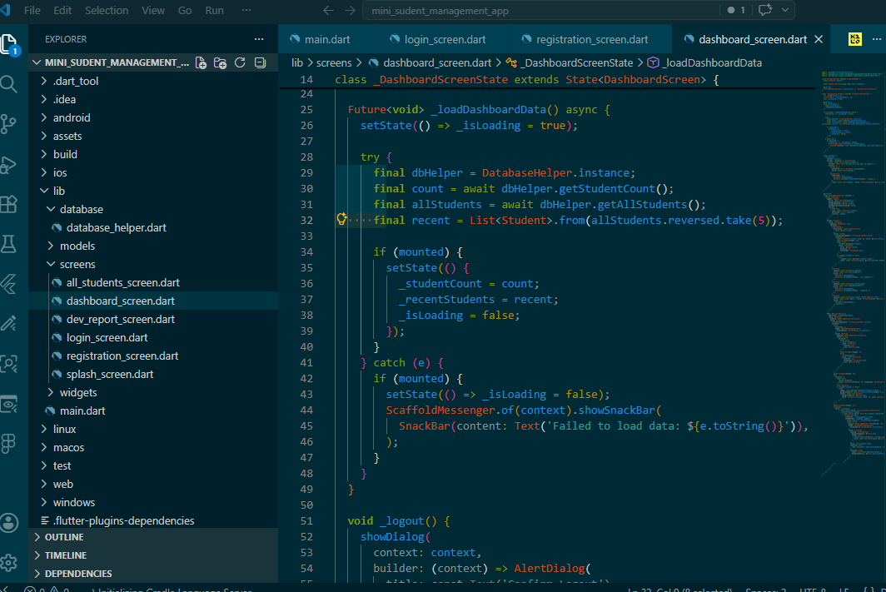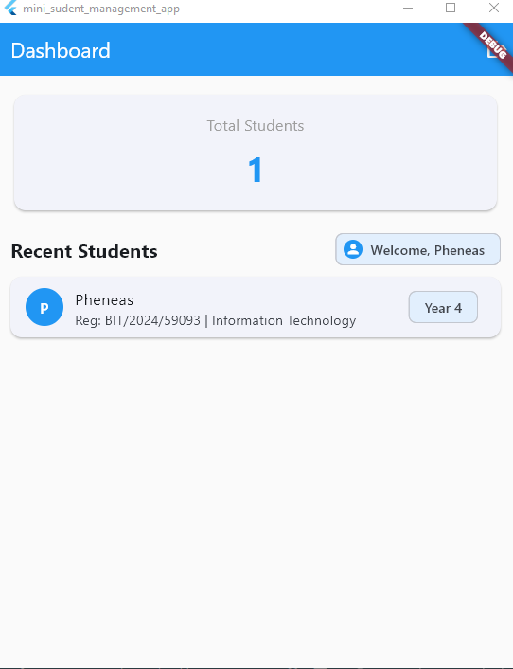
The main hub for a logged-in user.
- UI: Displays a personalized welcome message. The AppBar has no back button but includes a logout icon with a confirmation dialog. A navigation drawer provides links to "All Students", "Add New Student", and "Logout".
- Data: Shows a card with the total student count and a list of the last 5 registered students, each displaying a name initial avatar, registration number, course, and year.
- Interaction: Supports pull-to-refresh to reload data.
AllStudentsScreen (lib/screens/all_students_screen.dart)
A stateful widget displaying the complete list of students.
- UI: Contains a blue AppBar and a FloatingActionButton to add new students.
- List View: Shows each student with an initial avatar, name, and a subtitle with their registration number, course, and year.
- Edit: Tapping a student tile opens an alert dialog pre-filled with their data, allowing updates to the name, course, year, and phone number.
- Delete: A red delete icon on each tile triggers a confirmation dialog. Upon confirmation, the student record is deleted.
- Interaction: Supports pull-to-refresh.

6. MODEL: STUDENT (lib/models/student_model.dart)
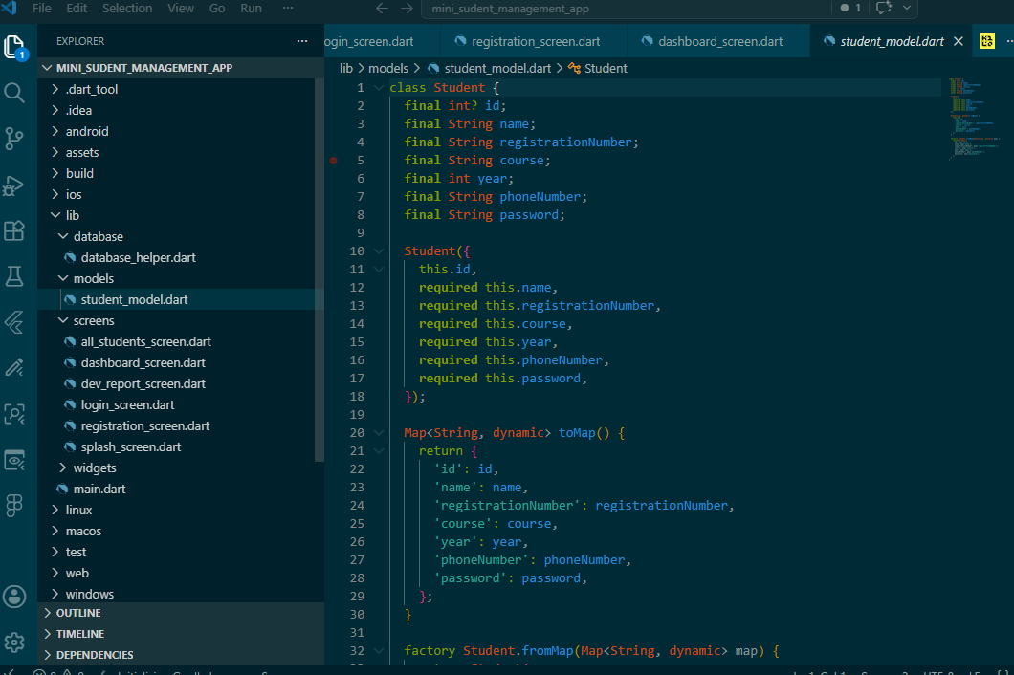
Defines the data structure for a student with the following fields: id, name, registrationNumber, course, year, phoneNumber, and password. It includes:
- A constructor with named parameters.
- A toMap() method to convert a Student object to a map for the database.
- A fromMap() factory method to create a Student object from a database map.
7. DATABASE HELPER (lib/database/database_helper.dart)
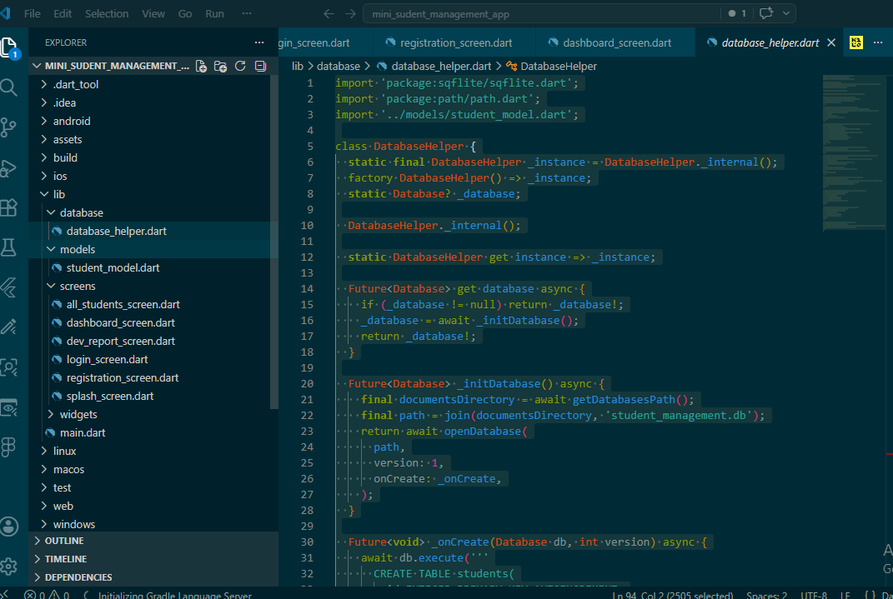
Manages the SQLite database using the singleton pattern.
- Database: Initializes a database named student_management.db and creates a students table with columns for ID, name, registration number, course, year, phone number, and password.
- Methods: Provides the following functions for CRUD operations:
  - insertStudent
  - getStudentByRegNumber
  - getAllStudents
  - updateStudent
  - deleteStudent
  - getStudentCount

